Garment | Size  (see guide) | Unit Price | Quantity | Total
Shirt – Straight sides |  | £34
Shirt – Half-tight |  | £34
Shirt – Tight (Ladies fit) |  | £34
Gillet – Men’s fit |  | £40
Gillet – Ladies fit |  | £40
Hoodie |  | £42
Core Compression Shirt |  | £31
Waterproof Jacket |  | £77

Name for front of shirt
Name for back of shirt
Left / Right Handed archer
Size Guide - Please order garments by the following measurements. The recommendation is to measure a shirt you are comfortable shooting in and use these measurements. If in doubt, go one size up.
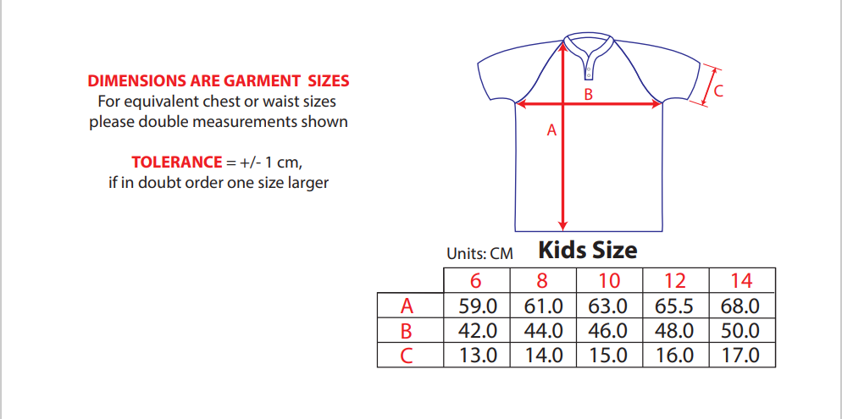
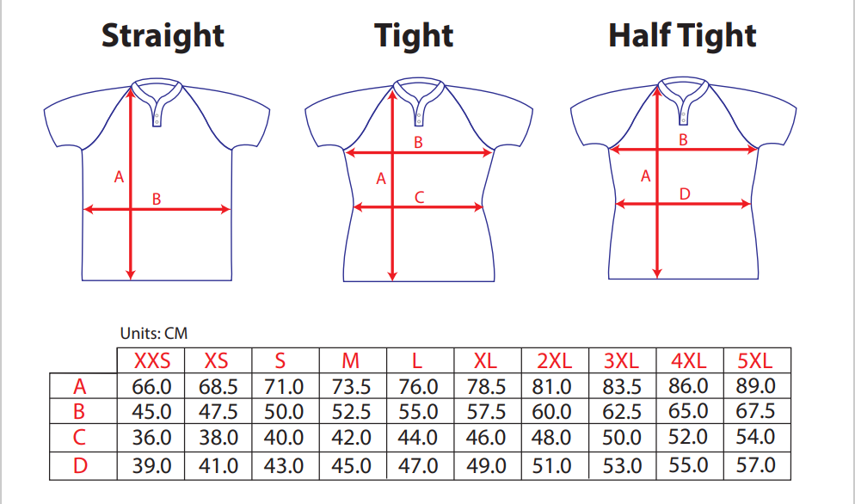

Please return the completed form to Deb (properteach@hotmail.com)
Please note, payment must be made by bank transfer at the time of ordering.
Bank Details
Sort Code 207289
Account No 80956082

Delivery will usually take up to 4 weeks from the time of ordering, and may take longer for individual garments.

