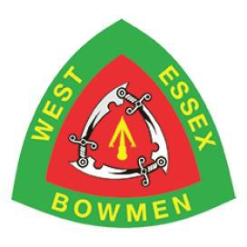
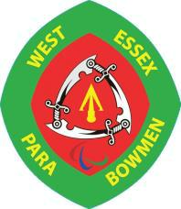
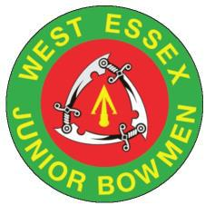

WEST ESSEX BOWMEN

Annual World Record Status Double Double 70m/50m FITA In Aid of Essex & Herts Air Ambulance Trust
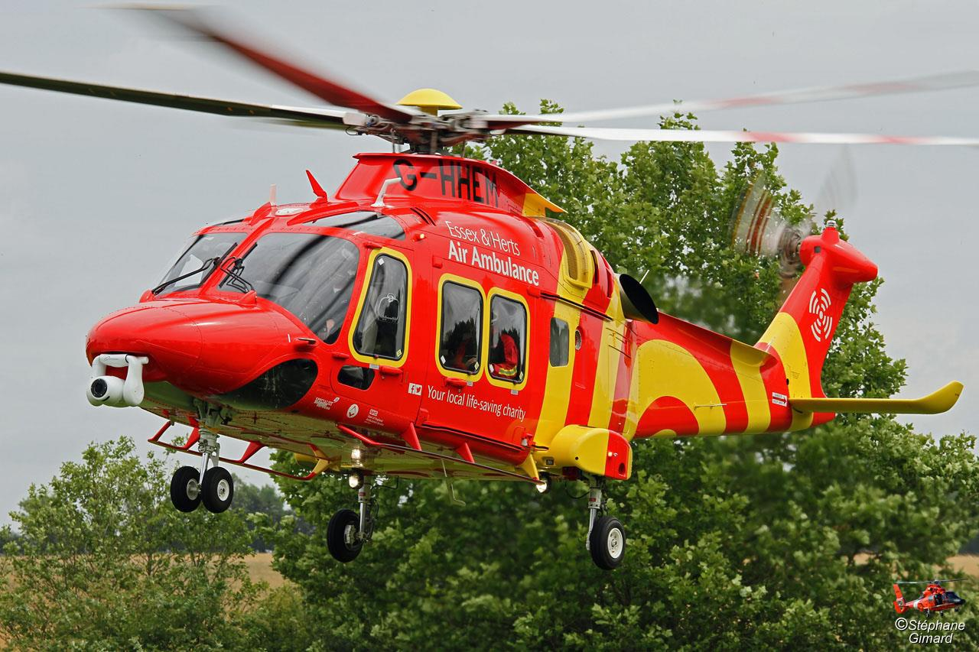

Date:

Saturday 25th April

and Sunday

26th April 2020

Round:

Double 70m/50m FITA on each day (World Record Status)

Venue:

Belhus Woods Country Park
Romford Road,
Aveley,
Essex
RM15 4XJ

Judges:

TBC

Lady Paramount:

TBC

Sighters:

9:30am on each day

Fee/Donation:

£15.00 per day (£10.00 goes to the Essex & Herts Air Ambulance Trust which is a registered charity in

England and Wales (1108989)
(Cheques made payable to West Essex Bowmen or Online at www.westessexbowmen.co.uk)

Rules:

Disclaimer:

GNAS regulations will apply. Archers may be asked to prove affiliation - non-cardholders should obtain a letter from
their secretary confirming application has been made.

Neither West Essex Bowmen, Essex & Herts Air Ambulance, Essex County Council, their agents and servants can

accept responsibility for any loss, damage or injury, howsoever caused. Please note that there are no dogs allowed
on the field

Car Parking:

Additional Info:

Parking anywhere in Belhus costs £5.50 per day (correct at time of entry form publication)

Overnight camping available on request

Closing date for entries 15th April 2019 or when full.

TITLE | NAME | M/F | Married | Snr/ Jnr |  | G.N.A.S | Style | Sat/Sun/
 |  |  | Couple |  |  |  | R, C, L/B, | Both
 |  |  |  |  |  |  | B/B

TOTAL

Club……………………………………………………………………… Date………………………

Contact………………………………………………………Tel…………………………………….

Address…………………………………………………………………………………………………

……………………………………………………………………………………………………………..
Completed entry forms and two SAEs (for target list and results) to be sent to:
Paul Tolson, 315 Parkmill Close, Corringham, ESSEX. SS17 7JR Tel: 01375 678737

By completing this form, you are agreeing to our privacy policy, copies of which can be found: http://www.westessexbowmen.co.uk/privacy-policy/

